Hi folks,

You might want to check out <https://www.hippocampus.org/>, an OER content library. It’s hosted by NROC, an OER member organization I was lucky to get to know in my last job. Their ethos is unlike typical vendor/for-profit ventures; they produce products in collaboration with their members--educational institutions (schools, school districts, colleges) across the country--so they’re really educator- and learner-centered. Hippocampus is one small slice of what they do. They also have math and English systems (free and subscription-based…very reasonable costs) to provide personalized learning pathways.

Here are a couple of navigation tips for Hippocampus.

**TOPICS. COLLECTIONS. SIGN UP FOR FREE ACCOUNT.**

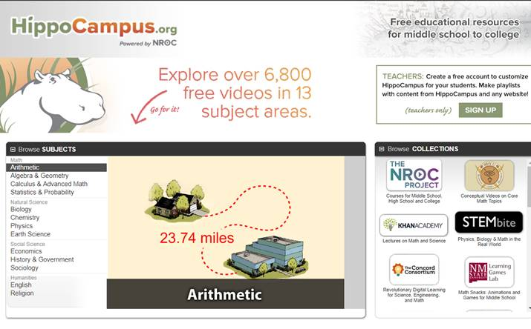

**Example: In the English section, scroll down and look on the right side under Links for already-created-playlists.**



