Annotated bibliography of Differentiation Books. If you want to borrow, check with Debbie, Chris, or Kathi; we all own different titles.

The Differentiated Classroom: Responding to the Needs of All Learners. Carol Ann Tomlinson.
Relevant for middle and high school. More theoretical.
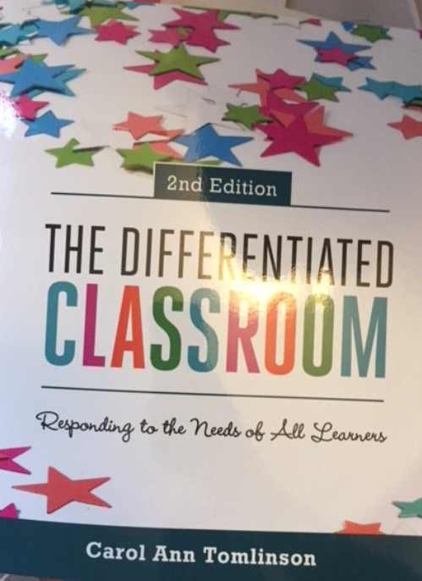

- What is a differentiated classroom?
- The underpinnings of differentiation
- Rethinking how we do school—and for whom
- Learning environments that support differentiation
- Good curriculum as a basis for differentiation
- Teachers at work building differentiated classrooms
- Instructional strategies that support differentiation
- More instructional strategies to support differentiation
- How do teachers make it all work?
- Education leaders as catalysts for differentiated instruction
Appendix: Tools to guide planning for differentiated instruction

How to Differentiate in Mixed-Ability Classrooms. Carol Ann Tomlinson.
A quick read, quick overviews of classroom structures for DI, especially the triumvirate: content, process, products.
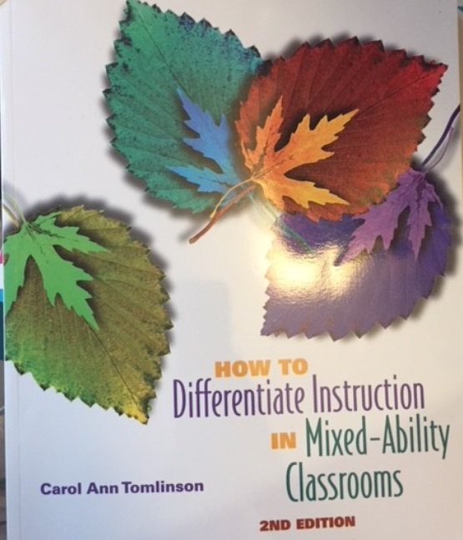

- What differentiated instruction is, and isn’t
- The rationale for differentiated instruction in mixed-ability classrooms
- The role of the teacher in a differentiated classroom
- The learning environment in a differentiated classroom
- Strategies for managing a differentiated classroom
- The how tos of planning lessons differentiated by readiness
- The how tos of planning lessons differentiated by interest
- The how tos of planning lessons differentiated by learning profile
- Differentiating content
- Differentiating process
- Differentiating products
- Grading in a differentiated classroom
Appendix: A few instructional and management strategies for differentiated, mixed-ability classrooms

Differentiation: From Planning to Practice, Grades 6-12. Rick Wormeli
Robust look at
- frame of reference
- walk-through of a differentiated lesson
- helpful structures and strategies
- cognitive science structures
- twelve samples of differentiated learning experiences from science, math, PE, art, writing

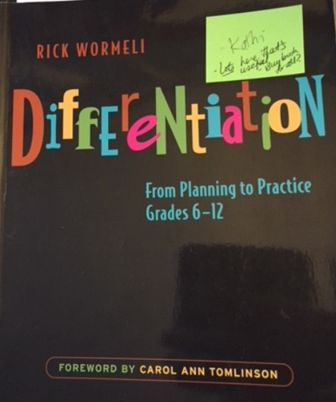

Advancing Differentiation: Thinking and Learning for the 21st Century. Richard M. Cash.
Sample lessons, reproducible forms on the included CD, PPT on CD for professional development. Part One focuses on curriculum, Part Two on the classroom—all with a deep emphasis on thinking skills.
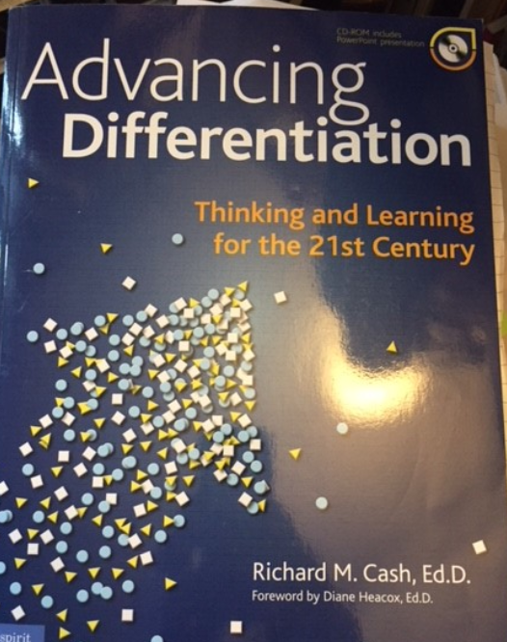

- Defining how differentiation looks in today’s classroom
- Defining the essentials of a differentiated curriculum
- Advancing differentiation to new levels through a rigorous curriculum
- Motivating and engaging learners
- Developing student self-regulation
- The teaching and learning continuum: building success through autonomy
- The thinking classroom
- A framework for thinking: digging deeper into Bloom’s Taxonomy
- Critical Thinking: developing reasoned thought
- Creative thinking: stepping outside the box
- Problem finding, problem solving, and decision-making

Designing a Differentiated Lesson Plan—From Scratch! Rick Wormeli.
Kind of like one big PPT. Topics include:
- Mastery
- Moving content into long-term memory
- Flexible groupings
- Tiering
- Anchor activities
- Learning menus
- Compacting
- 25 practical tips for supporting ELLs, pp. 98-112

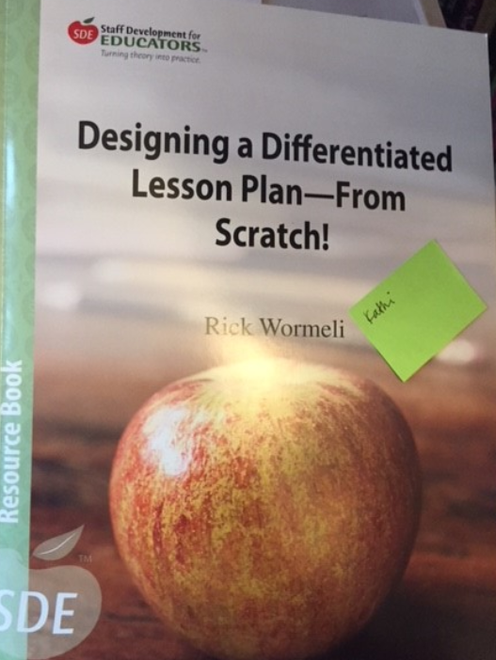

Differentiation and the Brain: How Neuroscience Supports the Learner-Friendly Classroom. David Sousa and Carol Ann Tomlinson.
The title captures the focus! There are several reproducible pages to use as planning tools.
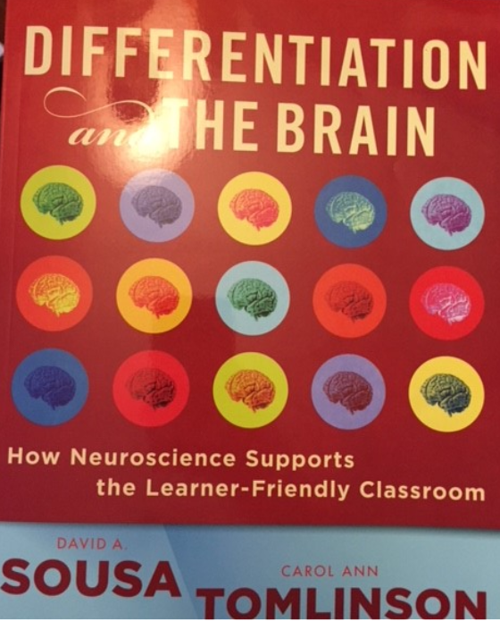

- The nonnegotiables of effective differentiation
- Mindset, learning environment, and differentiation
- Curriculum and differentiation
- Classroom assessment and differentiation
- Differentiating in response to student readiness
- Differentiating in response to student interest
- Differentiating in response to student learning profile
- Managing a differentiated classroom

Assessment and Student Success in a Differentiated Classroom. Carol Ann Tomlinson and Tonya R. Moon.
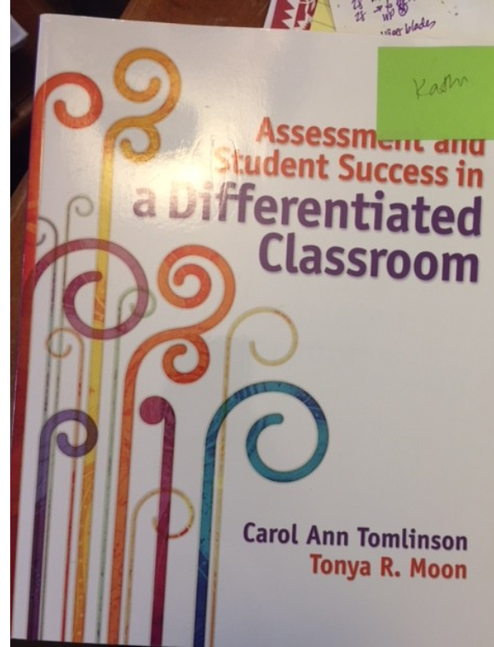
Focused on the interconnectedness of the five elements of teaching and learning--curriculum, instruction, assessment, learning environment, classroom management—and the importance of maintaining consistent focus on the essential knowledge, understandings, and skills that all students must acquire, regardless of their starting points.
- Differentiation: an overview
- Assessment and differentiation
- Pre-assessment: knowing where students are as a unit begins
- Ongoing assessment: knowing where students are as a unit evolves
- Summative assessment: measuring student learning at key points in a unit
- Assessment, grading, and differentiation
- A look back and ahead
Appendix: suggested readings in differentiated instruction

